Multiple-choice section

|  |  |  |  |  |  |  |
| --- | --- | --- | --- | --- | --- | --- |
| Question | 1 | 2 | 3 | 4 | 5 | 6 |
| Answer | D | A | B | D | C | B |

Question 1 [2.1]

D

*m*2 + *p*2 = *n*2

Question 2 [2.2]

A

*H*2 = 18.222 + 8.922

Question 3 [2.3]

B

*x*2 + 142 = 172

*x*2 + 196 = 289

*x*2 = 289 – 196

*x*2 = 93

*x* = 

Question 4 [2.4]

D

The bottom of the ladder is 1.2 m from the wall.

Question 5 [2.5]

C

When the numbers in (5, 12, 13) are multiplied by 3, the new triple is (15, 36, 39). None of the other sets are multiples of (5, 12, 13).

Question 6 [2.2]

B

*h*2 = 4.82 + 8.32

*h*2 = 23.04 + 68.89

*h*2 = 91.93

*h* = 

*h* = 9.588 01…

*h* ≈ 9.59 (2 d.p.)

Multiple-choice total marks: 6

Short answer section

Question 7 3 marks [2.1, 2.2]

The hypotenuse is the longest side of a right-angled triangle.  
The hypotenuse is opposite the right angle in a right-angled triangle.  
To find the length of the hypotenuse, we add the squares of the two shorter sides, then take the square root.

Question 8 2 marks [2.1]

**(a) (b)**

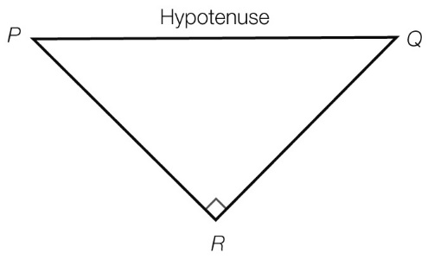 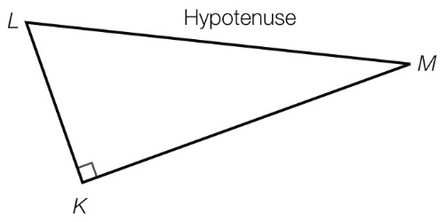

Question 9 1 mark [2.1]

Student working should be close to actual measurements.

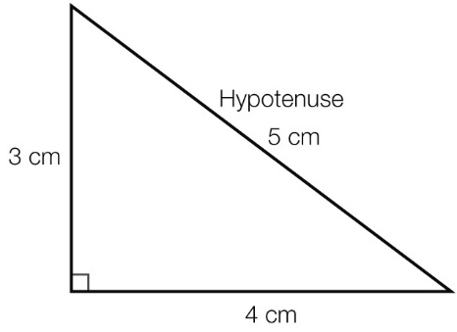

Question 10 2 marks [2.2]

3.12 + 3.72 = 23.3

4.92 = 24.01

The room is not ‘square’.

3.12 + 3.72 ≠ 4.92 so the corners are not right angles.

Question 11 6 marks [2.4]

|  |  |
| --- | --- |
| **(a)** | **(b)** |

**(c)**

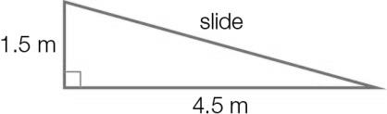

Question 12 3 marks [2.3]

p2 = 15.072 + 11.122

p2 = 350.7593

p = 

p = 18.73 (2 d.p.)

Question 13 2 marks [2.3]

*a*2 + 6.212 = 16.082

*a*2 + 38.5641 = 258.5664

*a*2 = 220.0023

*a* = 

*a* = 14.83 (2 d.p.)

Question 14 2 marks [2.3]

*x*2 + 112 = 132

*x*2 + 121 = 169

*x*2 = 169 – 121

*x*2 = 48

*x* = 

Question 15 3 marks [2.4]

Set 1:

322 + 1262 = 1024 + 15 876 = 16 900

1302 = 16 900

322 + 1262 = 1302, so Set 1 is a Pythagorean triple.

Set 2:

402 + 422 = 1600 + 1764 = 3364

572 = 3249

402 + 422 ≠ 572, so Set 2 is not a Pythagorean triple.

Short answer total marks: 24

Extended answer section

Question 16 5 marks [2.1, 2.5]

(a) Using the Pythagorean triple (3, 4, 5), *x* = 5.

Multiplying the numbers in (3, 4, 5) by 3 gives (9, 12, 15); *y* = 12.

(b) *p* is the hypotenuse of a right-angled triangle with shorter sides of 3 and 9.

*p*2 = 32 + 92

*q* is the hypotenuse of a right-angled triangle with shorter sides of 15 and 9 (from equal side marking).  
*q*2 = 152 + 92

Question 17 5 marks [2.3, 2.4]

(a) The 8.5 m long wire is the hypotenuse of a right-angled triangle. One of the shorter sides is formed by 7.5 m of the flagpole.

Let *x* m be the distance between the base of the flagpole and a peg.

From Pythagoras’ theorem:

*x*2 + 7.52 = 8.52

*x*2 + 56.25 = 72.25

Subtract 56.25 from both sides.

*x*2 = 16

*x* =  = 4

Each peg is 4 metres from the base of the flagpole.

**(b)** Each peg is 4 m from the base of the flagpole, so the distance between the pegs is 2 × 4 m = 8 m.

**(c)** Each wire is the hypotenuse of a right-angled triangle. Let *w* be the length of one of the wires. One shorter side is still formed by 7.5 m of the flagpole. The other shorter side is now only 2 m.

From Pythagoras’ theorem:

*w*2 = 7.52 + 22

*w*2 = 56.25 + 4

*w*2 = 60.25

*w* = 

*w* ≈ 7.76 (2 d.p.)  
There are two wires, so the total length of wire needed is 2 × 7.76 = 15.52 m.

Question 18 6 marks [2.2, 2.4]

**(a)** The line from *A* goes east 8 squares: 8 × 100 m = 800 m.

The next section of line is 12 squares long: 12 × 100 m = 1200 m. The direction is north.

The last section of the line is going east.

Abdullah walks 800 m east, then 1200 m north and then 300 m east.

**(b)** The total distance is 800 m + 1200 m + 300 m = 2300 m.

2300 m = 2.3 km

**(c)** The total distance east is 800 m + 300 m = 1100 m.

The total distance north is 1200 m.

A straight line from *A* to *B* is the hypotenuse of a right-angled triangle with shorter sides of 1100 m and 1200 m.

Let the straight-line distance be s m.

s2 = 11002 + 12002

s2 = 1 210 000 + 1 440 000

s2 = 2 650 000

s =

s ≈ 1628 (nearest whole number)

Abdullah has to walk 1628 metres in a straight line from *A* to *B*.

Extended answer total marks: 16

TOTAL test marks: 46